國立高雄科技大學各系(所)博碩士撰寫畢業論文須知

英文延伸摘要(Extended Abstract)撰寫格式說明

字體大小及段落
- 論文題目：字體大小為14字元，粗體字，置中。
- 作者資料：字體大小為12字元，標準字，置中，含作者姓名、指導教授姓名、所屬學院及系所。
- 摘要字及關鍵字：內文標題(如INTRODUCTION)之字體大小為12字元，粗體字，置中 ，所有字母大寫；摘要內容及關鍵字字體大小為12字元，標準字。摘要內容每一段開頭無需空字元，關鍵字列於SUMMARY摘要後。
- 段落為單行間距。
(5) 範例及詳細說明如附件。

Thesis/Dissertation Title
Author’s Name Advisor’s Name
Department & College
SUMMARY
The summary is a short, informative abstract of no more than 250 words. References should not be cited. The summary should (1) state the scope and objectives of the research, (2) describe the methods used, (3) summarize the results, and (4) state the principal conclusions. Text of the summary should be 12 pt Times New Roman font, single-spaced and justified. A single line space should be left below the title ‘SUMMARY’. Leave a single line space above the key words listed below.
Key words: Maximum 5 key words in 12 pt Times New Roman, separated by commas.

INTRODUCTION

The purpose of the introduction is to tell readers why they should want to read your thesis/ dissertation. This section should provide sufficient background information to allow readers to understand and evaluate the paper’s results.
The introduction should (1) present the nature and scope of the problem, (2) review related literature,
(3) describe the materials used and method(s) of the study, and (4) describe the main results of the study.
All text in the main body of the extended abstract should be 12 pt Times New Roman font,
single-spaced and justified. Main headings are placed in the centre of the column, in capital letters using 12 pt Times New Roman Bold font. Subheadings are placed on the left margin of the column and are typed in 12 pt Times New Roman Bold font.

MATERIALS AND METHODS

There is flexibility as to the naming of the section (or sections) that provide information on the method(s) or theories employed. The methodology employed in the work must be described in sufficient detail or with sufficient references so that the results could be duplicated.
Your materials should be organised carefully. Include all the data necessary to support your conclusions, but exclude redundant or unnecessary data.

RESULTS AND DISCUSSION

The results and discussion sections present your research findings and your analysis of those findings. The results of experiments can be presented as tables or figures.

Figures and Tables

Figures may be integrated within the results section of the extended abstract, or they can be appended to the end of the written text. Figures should be black & white. They should be no wider than the width of the A4 page.
Tables can be created within Word. As noted for figures above, if a table is to be placed within the text, it can be no wider than the width of the A4 page. Larger tables will need to be placed at the end of the abstract.
Figures and tables should be numbered according to the order they are referenced in the paper. Figures and tables should be referred to by their number in the text. When referring to figures and tables in the text, spell out and capitalize the word Figure or Table. All figures and tables must have captions.

Captions

Captions should clearly explain the significance of the figure or table without reference to the text. Details in captions should not be restated in the text. Parameters in figure captions should be included and presented in words rather than symbols.
Captions should be placed directly above the relevant table and beneath the relevant figure. The caption should be typed in 12 pt Times New Roman Bold font. Spell out the word 'Table' or ‘Figure’ in full. An example table and a figure follow.

Table 1. Specifications of the engine
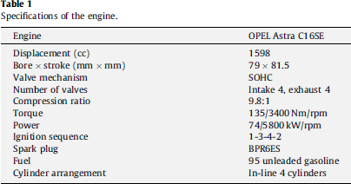
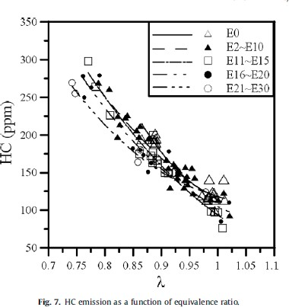

Figure 1. HC emission as a function of equivalence ratio CONCLUSION
This section should include (1) the main points of your paper and why they are significant, (2) any exceptions to, problems with, or limitations to your argument, (3) agreements or disagreements with previously published work, (4) theoretical and practical implications of the work, and (5) conclusions drawn.

